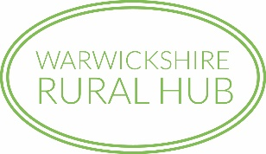

Warwickshire Rural Hub
Environmental Farming Award

Awarded for excellence in integrating farming and
conservation on a commercial Warwickshire farm

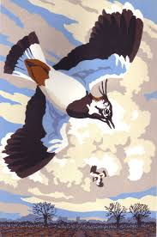

2021
Application Form

Sponsored by:

ENTRANT’S DETAILS

Name:
Address:
Tel: No:
Email:
ABOUT THE FARM (please tick appropriate boxes)

Total Farm Area (Ha): | Under 100 | 100 – 300 | Over 300
Enterprise Type(s)

Dairy |  | Beef |  | Sheep
Pig |  | Poultry |  | Other
Arable operations

Combinable  Crops |  | Grassland |  | Root Vegetables
Woodland |  | Poultry |  | Other

ABOUT THE FARMING OPERATIONS

Environmental impact considerations

Have you implemented any of the following measures?

 | Yes | No
Resource protection (of air, soil and water)
Resource management (soil and water)
Effective manure/fertiliser management
Waste management/recycling
An Integrated Pest Management strategy

Which features on your farm have you managed for the benefit of wildlife, landscape or historical conservation?

 | Yes | No
Woodlands
Ponds/wetlands
Hedges
Grassland (improved and unimproved)
Field margins
Wildflower meadows
Winter bird seed plots
Pollen and nectar mixes
Beetle banks
Other (please specify)

 | Yes | No
Have you started to change your farming practices to adapt to climate change?

Do you promote your farm and conservation work to the farming community and general public?

 | Yes | No
Farm website
Twitter
Instagram
Facebook
Open Farm Sunday
Other farm open days/school visits
Other (Please specify)

CONDITIONS OF ENTRY

WINNER

The award is given annually to the farmer in Warwickshire who, in the opinion of the judges, has undertaken the most work to integrate conservation of wildlife with commercial farming activity. Consideration will be taken to include flora and fauna but must also be given to landscape and historical interests.

WHO CAN ENTER
Entries are invited from all farmers, farm managers and landowners running a farm with a Warwickshire holding number, whether tenants or owners. A previous winner of the Award must wait three years before he/she can re-enter.

CONDTIONS OF ENTRY
When you have completed your entry, please send this application form to the Rural Hub Co-ordinator at info@ruralhub.org.uk or Warwickshire Rural Hub, c/o Archway Cottage, 2 Church Street, Marton, Rugby CV23 9RL.

After the closing date of the competition entries will be reviewed and a shortlist will be contacted to arrange for the judges to be shown around your farm in late May. The judges’ visit will take a maximum of 2 hours and will involve them assessing your farming practices, resource management, management of wildlife features within the context of the farming system, the future proofing of the farm and promotion of the farm to the general public. The marks for each section are not equally weighted.

The winner will be presented with the Warwickshire Rural Hub Environmental Farming Award prize for 2021, a winner’s certificate and a Syngenta voucher for £100.

The winner will be publicised in the Warwickshire Rural Hub E-news, website and social media accounts.

The winner will be asked to host a Warwickshire Rural Hub walk in summer 2022. Syngenta will provide refreshments at the walk.

Entries must comply with the above conditions. The decision of the judges is final.

Entries must be received by: 10th May 2021

I have read the conditions of entry and would like to be considered for the
Warwickshire Rural Hub Environmental Farming Award

Signature (or name): |  | Date:

